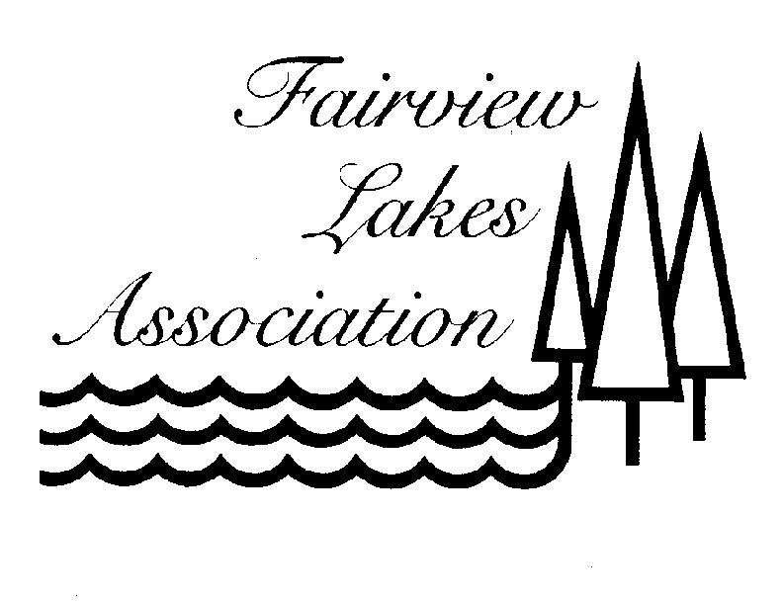
Board Members, Officers, Ombudsman and *Advisors – Nov. 2016

President Financial Director
Paul Talbot (Sandie), Lot 165 Matthew Simonsen (Malerie), Lot 34
838 East 700 South 162 Sky Hawk Way
Springville, UT 84663 Elk Ridge, UT 84651
(801) 368-6074, cell (801) 201-0002
Email: pjtcpa@msn.com Email: msimonsen@cbutah.com

Secretary/Treasurer Engineering (Roads) Director
Cindy Henry (Neal), Lot 32 Dale Robinson (Sharon), Lot 32
1736 Fairway Lane 739 East 100 South
Spanish Fork, UT 84660 Spanish Fork, UT 84660
(801) 787-6955, cell (801) 798-7180, home
Email: cindyh@squire.com (801) 921-9810, cell
Email: daler@spanishfork.org

Environmental (Water) Director Safety Director
Steven Mower (Sally), Lot 127 Lynn Williams (Connie), Lot 166
11172 North 5650 West 905 West 1490 North
Highland, UT 84003 Orem, UT 84057
(801) 756-8245, home (801) 225-8882, home
(801) 420-5708, cell Email: lpwillie@yahoo.com
Email: sallymower@digis.net

Security Director Architectural Director
Mark Beck (Laura) Lot 100 Troy Worthington (Collette), Lot 96
14 W Main 326 West 4100 North
Mt. Pleasant, UT 84648 Provo, UT 84604
(435) 851-3080, cell (801) 358-8822, cell
Email: markbeck@cut.net Email: troy@alpinebenefits.com

Ombudsman Corporate Council Gregg Tobler*
Robyn Hall, Lot 15 Lot 1 (801) 491-8587
1843 North 1300 West
Pleasant Grove, UT 84062 Web Master – Blake Jensen
(801) 319-2013, cell bjensen41@yahoo.com
Email: rhallpt@hotmail.com

HOST CABIN TELEPHONE (801) 885-9933 Accounting Larson* & Company

765 No. Main, Spanish Fork, UT 84660
Call Jessica at (801) 798-3545
Email: jdonaldson@larsco.com

*Member

